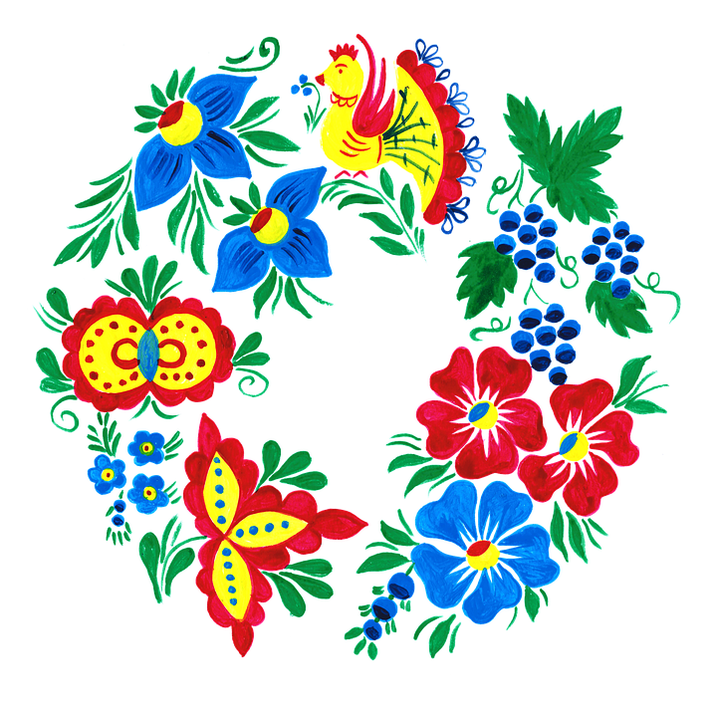
Miss Czech-Slovak WI Pageant Official Rules and Procedures
Queen’s Royal Court

Rules
- Contestants must be of partial Czech, Slovak, Silesian, Moravian or Rusyn descent or be legally adopted by parents of this descent.
- Contestants must never have been married and cannot be an unmarried mother.
- Contestants must be between 13 and 17 years of age
- She must be attending school.
- Contestants must appear in a Czech, Slovak, Silesian, Moravian, or Rusyn folk dress.
- Contestants must be personally present and participate in all three pageant categories and all pageant scheduled events as scheduled per pageant committee. The categories in order are: Private Interview by advisors, Kroj Modeling, and Talent Presentation.
- Contestants will also write and present a heritage essay of approximately 250 words. She should describe what her heritage means to her.

Procedures:
- Contestants must attend the Friday afternoon orientation.
- Contestants must attend the Friday evening Lidice Memorial Service.
- Contestants must attend the Saturday evening Polka Mass service if the committee chooses this as an activity.
- Contestants must attend the nursing home visitation.
- Little Sisters will be appointed by the Miss Czech-Slovak WI Pageant Committee.
- Queen’s Royal Court will receive a sash provided by the Miss Czech-Slovak WI Pageant at the beginning of the Pageant if they do not already have one.
- Queen’s Royal Court members who previously received a tiara and sash should wear them for the duration of the pageant.

Contestant’s Entry Information
- Entries must be postmarked by May 31.
  - Email : langelo6546@gmail.com
  - Mail: Luanne Angelo 124 N. Eyder, Phillips, WI 54555
- Changes to the entry form, kroj description, or questions will be accepted after with permission is given by the Miss Czech-Slovak WI Pageant Committee.
- The following parts must be included in the Contestant’s Entry Packet.
  - Entry form and Application Questions
  - Kroj Description
  - Copy of Family Tree or brief description to show heritage.
  - Heritage Essay
  - Contestant Headshot. Does not need to be in kroj. Must be of quality to submit to newspaper. May be either digital (via email to langelo6546@gmail.com or photo. Photos will not be returned.

- Google and/or Word documents may be shared as well. This is actually preferable for kroj description.
Individual Category Rules

Private Interview
- Contestants must be interviewed in the same kroj she presents during the kroj modeling category.
- Contestants will receive a four (4) minute interview, panel-style with the judges.
- All contestants will receive the same three questions.
- There will be a timer present in the room who will announce when 30 seconds are left. Contestant should finish answering the current question at that point.

Kroj (Costume)
- A written description of no more than 250 words must be sent with the entry form. The description should be written in 3rd person and will be read aloud as you model your kroj on the stage during the kroj competition. For example: Suzi is wearing a Plzen kroj created with family assistance. If the description is more than 250 words, the State Pageant Director will edit the contestant’s description.
- Kroj descriptions should include (but not limited to): the origin, how it represents your family, if any element/s is/are authentic or replicated, the meaning of the kroj and its physical description. Get a bit personal with your kroj description. Tell what is important to you/favorite part about the kroj. Write your description as if you were describing it to someone blind.
- All contestants must end their description of their kroj with footwear.
- Kroj descriptions should be either submitted as a Google Doc (shared to langelo6546@gmail.com), or a Word Document, a pdf, or a physical paper included with the entry packet.

Talent:
- Talent presentations are limited to no more than four (4) minutes. Presentations begin with a formal introduction and conclude with final work, note, or motion.
- Contestants are encouraged, but not mandated, to introduce their talent including: what talent they will be performing, why they chose their talent and how it relates to the contestant. The introduction is part of the four (4) minute time.
- Talent presentations are limited only by your imagination and our stage capabilities! Past examples include singing, dancing, playing a musical instrument, dramatic reading, skit, art display, dress designing, poetry, drawings, gymnastics, verbal oration on a subject.
- Pre-recorded and pre-created props will not be considered/judged in the overall performance. This is about you. If a recording is used for musical accompaniment, it must be instrumental with no background vocals. An on stage accompanist is allowed but no other partners can perform with contestant.
- Contestants must describe their talent in detail on their entry form.
- Contestants are responsible for all props for their talent. Pageant will supply microphone, keyboard (if known ahead of time), and sound system.

Heritage Essay
- Contestants will write a heritage essay describing what their Czech, Slovak, Rusyn, Silesian, or Moravian heritage means to them.
- Contestants will present their essay at some point in the pageant.

Traditional Prizes

Queen’s Royal Court will receive:
- Tiara & sash unless they have already received one.
- Feedback from advisors to help them in the future.

Questions may be directed to Luanne Angelo, WI State Pageant director
Email: langelo6546@gmail.com
Cell/Text: 414-436-5162

